


Application
for
SPONSORSHIP

PART I - EXECUTIVE SUMMARY
Summarize your project in less than 200 words with the following points:
- Mission and purpose of your project
- Total amount of funds required
- How much is being requested from RFOH (up to $5000)
- Intended use of RFOH funds
- Collaborations with partner organizations

PART II - APPLICANT INFORMATION
Provide a separate document if necessary for each question. If you need help, do not hesitate to contact us.

- Amount of funds requested from RFOH:
- Organization’s full legal name:
- CRA charitable registration number (required):
- Are you in good standing with the CRA Charities Directorate? Yes No
- Your website, if applicable:
- Your Facebook page, if applicable:
- Your Instagram, if applicable:
- Your LinkedIn, if applicable:
- Contact information
  - Name:
  - Title & Role:
  - Email:
  - Phone number:
  - Mailing address:
- Your affiliation with other organizations
  - Sponsorship Agreement Holder (SAH) Yes No
  - Co-sponsor (e.g., Rainbow Refugee) Yes No
  - Constituent Group (CG) Yes No
- List affiliated charities with contact person & CRA charity registration number.

Affiliated Organization | Contact Person | Contact Information | CRA Charitable Registration

- Are you matched with an LGBT+ Refugee to sponsor? Yes No
  - If not, how do you intend to find someone to sponsor (100 words)?
  - If so, describe the IRCC sponsorship application progress (100 words)?

PART III - REFUGEE INFORMATION
- Is the refugee currently outside the country of origin? Yes No
- Is the persecution due to sexual orientation, gender identity or expression (SOGIE)? Yes No
- Is the refugee registered with the UNHCR? Yes No
- Is the refugee being sponsored a BVOR candidate? Yes No
  - If so, when do they arrive in Canada? DD MMM YYYY
- Who do you want to sponsor and what is their story? Provide details you can safely share such as country of origin, situation, and how you came into contact.

PART IV - SPONSORSHIP PROJECT DESCRIPTION
This section provides the Review Subcommittee with a description of the project and how funds will be used.
- Has the sponsoring organization already raised any funds? Yes No
- Is the amount enough to submit an application to IRCC? Yes No
- If so, has IRCC already accepted the application? Yes No
- Do you plan to raise more funds? Yes No
- Will you use the federal Rainbow Refugee Assistance Program? Yes No
- Have you included a Settlement Plan with the application? Yes No
To help us understand the level of need and your plan for resettlement, please complete the following section.
- Describe the sponsorship process in 200 words or less.
- Describe your goals in 100 words or less.
- Describe your experience with refugee sponsorship in 200 words or less.
- As part of the COLLABORATION with other groups, concisely describe how the affiliated groups will participate. Describe any fundraising initiatives and information about other sources of funds you plan to use. Include the associated amounts of and costs expected in addition to the amount requested in this application in 300 words or less.
- Describe a clear PLAN OF ACTION with key milestones and a realistic timeline for completion of the project. Include all of your team members and affiliated organizations in 500 words or less.
- If applicable, state as a percentage or value the total amount of this grant you plan to use for administration or overhead expenses.

PART V - BUDGET
Itemize project costs and how you raised funds. Include funding required in addition to your request from RFOH. Indicate if and how the project will go ahead if RFOH can only supply part of the requested amount. Include all project-related expenses in the table.
Item | Description of Costs and Funding Sources | Amount
1.
2.
3.
4.
5.
6.
7.
8.
9.
10.
11.
12.
13.
14.
15.
16.
17.
18.
19.
20.
Total amount requested from RFOH:
Total cost of project (sum of funds from all sources):

PART VI - MEASURES FOR SUCCESS
As a volunteer organization and registered charity, RFOH is accountable and transparent to its contributing membership of volunteers and donors. Applicants must uphold these tenets as a commitment to ongoing success.
- What will be the outcome of the project? (maximum of 200 words).
- How will you share the impact and benefit of the grant with RFOH? Include an update of progress, any photos, beneficiary statements, etc... Please also indicate any level of involvement by RFOH outside of funding.

PART VII - REPORT ON SUCCESS
Rainbow Foundation of Hope aims to balance the administrative impact of reporting by grant recipients with the need to report on benefits of our grants. It helps to continually improve the process and share benefits with donors and volunteers to sustain the work.

Send us a report within two (2) months of the project completion or within a year of receiving the award, whichever comes sooner.

PART VIII - SUBMIT YOUR APPLICATION
- Provide the application as a Word document or PDF.
- Send the application to grants@foundationofhope.net once it is complete.
- Include “RFOH SPONSORSHIP SUPPORT GRANT” in the email subject line.
- Answer all questions as specified in the guidelines and this application.
- Use an email address directly related to your organization and its website.

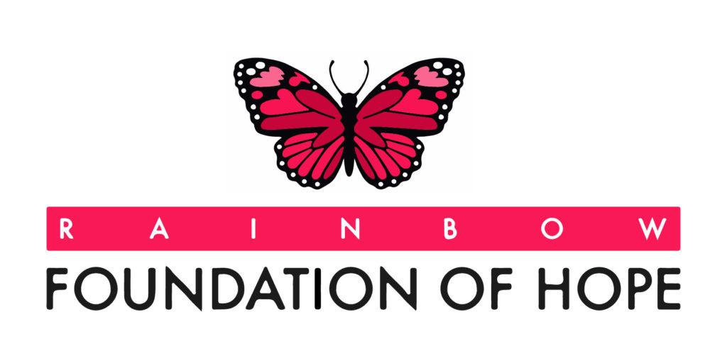
Copyright © 2024

